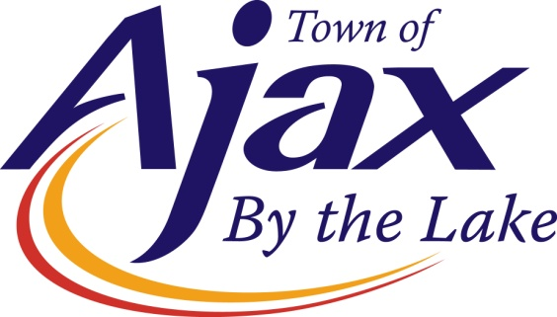**Operations Technologist - Permits and Inspections**

Reporting to the Supervisor of Technical Services and Maintenance Contracts, the Operations Technologist is responsible primarily to provide a wide range of technical services relating to municipal permits and inspections, provide and support in contract administration for a variety of maintenance contracts, as required.

**Job Duties Include**

The responsibilities and duties of this position includes but is not limited to:

* Administer the Road Occupancy Permit (ROP) Process
* Manage and administer Municipal Consent (MC) applications and issue MC approval documentation to utility Applicants
* Provide guidance to Applicants regarding MC, ROP application, road closures, construction safety and public notifications, and traffic control plans
* Conduct Right of Way inspections for Road Occupancy applications and permit, and Parkland Crossing applications.  This includes: pre, progress, and final inspections including documentation, photographs, measurements, and record keeping
* Inspect right of way deficiencies in accordance with the Town standards, Municipal and provincial legislations (MMS, hard and soft surface restorations)
* Identify safety hazards within road allowance during inspections and report them to Town By-Law and appropriate stakeholders:  contractors, utility owners, and agencies
* Review various professional engineering drawings such as but not limited to permit applications drawings and development progress drawings
* Provide support in contract administration for a variety of maintenance contracts such as but not limited to:  Curb Cutting, Crack Sealing, Surface Discontinuity, etc., as required
* Provide excellent customer service, investigate, and resolve complaints
* Perform and support other related duties and research as assigned that are in accordance with general job responsibilities or necessary departmental or corporate objectives

**Qualifications/Skills**

* **Education/Experience:** 3 year college diploma in Civil Engineering Technology with four (4) years of relevant Civil Engineering experience or a combination of education, training and relevant work experience deemed equivalent.
* **Professional Designations:** Certified Engineering Technologist (C.E.T.) designation from the Ontario of Certified Engineering Technicians and Technologists (OACETT).
* **Technical Experience:** Knowledge in Civil Engineering with emphasis in municipal infrastructure and Ontario Provincial Standards.  Excellent Knowledge and ability to read, interpret and provide comments on technical engineered drawings, and civil construction techniques.
* **Legislation:** Understanding of the Highway Traffic Act (Book 7 Temporary Conditions), Ontario Municipal Act, Minimum Maintenance Standards and the Occupational Health and Safety Act (OHSA).
* **Communication Skills:** Excellent communication skills (both verbal and written) and interpersonal skills.
* **Other Skills:** Exceptional customer service skills, with the proven ability to resolve conflict. Superior organization, time management, planning, and record keeping skills. Strong decision making skills and ability to work with minimal supervision
* **Other Related Qualifications:** Strong computer skills relating to Microsoft Word, Excel. Valid Ontario Class “G” Driver’s License in good standing.

**Nice to Have**

* An understanding of other specialized software applications (i.e., CityWorks, AMANDA).

**What is offered to staff**

* **Rate of Pay**: $39.48 - $42.09 per hour ($82,118 - $87,547 per year)
* **Hours of Work**: This is a unionized position that works a 40 hour work week. The hours of work are Monday to Friday from 7:30 a.m. to 4:00 p.m. and are in accordance with the Collective Agreement.

**How to Apply**

To apply for this exciting opportunity, please go to the Town of Ajax website at

[www.ajax.ca/careers](http://www.ajax.ca/careers).

**Equal Opportunity Employer**

The Town of Ajax is an equal opportunity employer, committed to diversity and accessibility within the workplace where all employees feel valued, respected and supported.  The Town embraces diversity and gender expression through policy, staff training and providing positive spaces. The Town encourages applications from all qualified candidates. If selected for an interview, please inform Human Resources staff of any accommodation you may require during the process.